***Functional Design***

*Version 1.4.*



*Name: Aron Dosti*

*Student id: 115827*

*Date: 17/05/2020*

*Table of contents*

*1.Introduction …………………………………………………………………………………………………………………………………..3*

*2.Summary ……………………………………………………………………………………………………………………………………… 3*

*3.Functionalities ………………………………………………………………………………………………………………………….….. 3*

*4.Sitemap ……………………………………………………………………………………………………………………………………….. 5*

*5.Basic screen layout ………………………………………………………………………………………………………………………. 5*

*6.Navigation structure ...…………………………………………………………………………………………………………………. 6*

*7.Use case ………………………………………………………………………………………………………………………………………. 7*

*8.Wireframes ....................................................................................................................................... 8*

9.Datamodel ....................................................................................................................................... 10

*10.Security and Access ........................................................................................................................ 10*

*11.User screens ……………………………………………………………………………………………………………………………... 11*

*12.Version control …………………………………………………………………………………………………….…………………… 11*

13. *Additional ..................................................................................................................................... 12*

# 1.Introduction

In this Functional document there will be all the requirements and Information that are important for the Hotelkeeper (customer). This document contains:

* The introduction (short explanation.)
* *Summary ( explenation about the document.)*
* Functionalities (explaining the requirements that are needed for this website in MosCoW method.)
* *Sitemap (Information about all the pages and files.)*
* Basic screen layout (layout of the website such as color.)
* Navigation structure (explaining how to navigate within the application/website.)
* Use case (a sketch of a scenario or action that will be happening for on the website.)
* Wireframes (Sketch of every webpage of the hotel website.)
* *Datamodel (a diagram with tables of data that have a relation with each other.)*
* Security and Access (Safety locks and protection for the website, Also accessibility.)
* User screens (Explaining how the user will get directed through the website.)
* Version control (here there will be kept by when a new version is made and dated.)
* Additional (there may be small Information that I want to add.)

# 2.Summary

To summarize this document for you, there will be explaining about all the Functions that are being used for this website and design examples will be shown for the viewers. Not only that but there will also be an explanation about the Moscow analysis, sitemap, basic screen layout, navigation structure, use case, datamodel, security and access and Additional things might be important. At last there will be sketches of the wireframes. We have to keep in mind that this document is still under maintenance and the versions of the Functional design might get changed, but no worries the old version files will be kept and dated so that we can look back at old information of the Functional Design. A date will also be kept by.

# 3.Functionalities

The method we use in Functionalities is the MoScoW method. The MoScoW method consists of must have, should have, could have and won’t have. Here are the **MUST** have functions that we need to make the website work (keep in mind that these Functions are not categorized in an order):

1. The hotelkeeper must be able to add the category of rooms available in the system.
2. The hotelkeeper must be able to see a room plan with the location of the rooms.
3. In the room plan the hotelkeeper must be able to assign the category that the room belongs to.
4. The hotelkeeper must be able to print a list of rooms and the category they belong to.
5. The front desk must be able to register a guest as an occupant of a room.
6. The front desk must be able to see if the room is prepaid or post-paid.
7. In the case of a post-paid room, the front desk must be able to print an invoice for the room rent (free) that is due.
8. The reservation desk must be able to assign a room price for one of the 3 categories of rooms for a certain day of the year. The pricing system must be filled in, at least 3 months in advance.
9. The reservation desk must be able to retrieve a list of room prices per day. They also must be able to print this list.
10. Web visitors must be able to see the available categories of rooms and prices for those categories from a certain start-to an end date.
11. The web visitor must be able to make a reservation.
12. The hotelkeeper must be able to see and print a list of occupied and reserved rooms within a certain period.
13. The front desk mustbe able to print a list of room prices for a week.
14. The front desk must be able to see all unoccupied and the amount of not reserved (vacant) rooms on a certain day per category.

Now that the must haves are listed, here are the **SHOULD** have (the ones we should need for this website to work):

1. The Hotel website should have a calendar.
2. The Hotel website should have an admin panel for the administrators to make modifications or to be able to view reservations.
3. The Hotel website should have a login system. This will be for both customers and administrators.

Now for the **COULD** haves (the could haves are the one we could need):

1. There could be an Invoicing system for the mini bar usage during a stay.
2. There could be a Ticket system for room service (chef and waiter).
3. There could be a possibility to Connect room service tickets to the invoicing system.
4. There could be a There could be a Cleaning roster with the most efficient route.
5. There could be a Cleaning alert on the floormap at checkout.

At last here are the **WON’T** haves (the ones we will not have):

1. The website Won’t have any other languages than English.
2. The website won’t have a customer support service (as in chatting with staff members) but there will be contact information for questions.
3. The website won’t have discounts (for now).

# 4.Sitemap

The sitemap explains what pages you have and what they consist of:

* Home
* Hotel California
* About us
* Staff and others
* Book a room
  + Category/options
* Single room
* Dual room
* Family room
* Luxury room
* Etc…
* Contact
* Contact us
* Login/register
* Create Account/Login
* View option
* Booking/reservation display.

# 5.Basic screen layout

The website will consist of:

* colors (gold, brown and gray. This may change)
* Fonts (the choices are: Serif, Sans serif, Montserrat, Jost, Ostwald and Roboto Condensed)
* Pictures (these will be taken over from:
* <https://unsplash.com>
* <https://pexels.com>
* <https://pixabay.com>) (they are free of use)
* Code/script (the code will be written in PHP code only).

# 6.Navigation structure

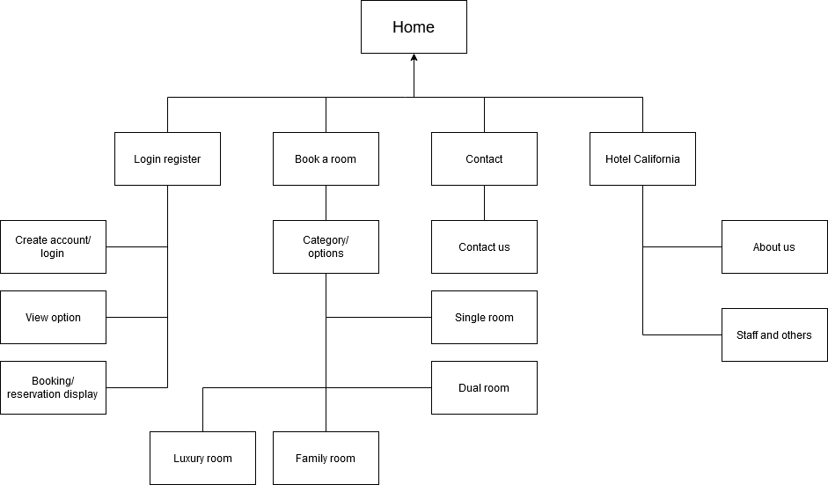

# 7.Use case

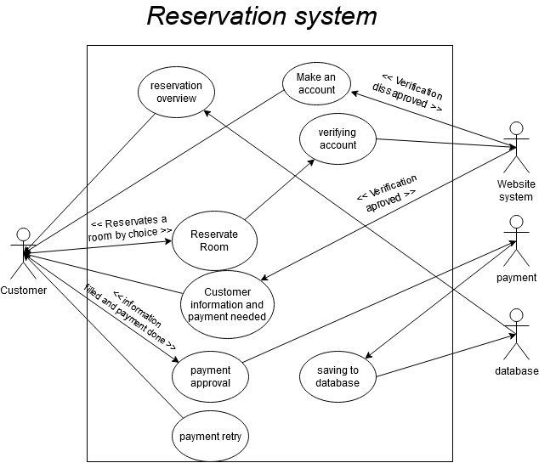

# 8.Wireframes

Wireframes are sketches of all the website pages. keep in mind that these sketches aren’t accurate yet and the outcome of the website will and may look different. The following wireframes:

***Home***

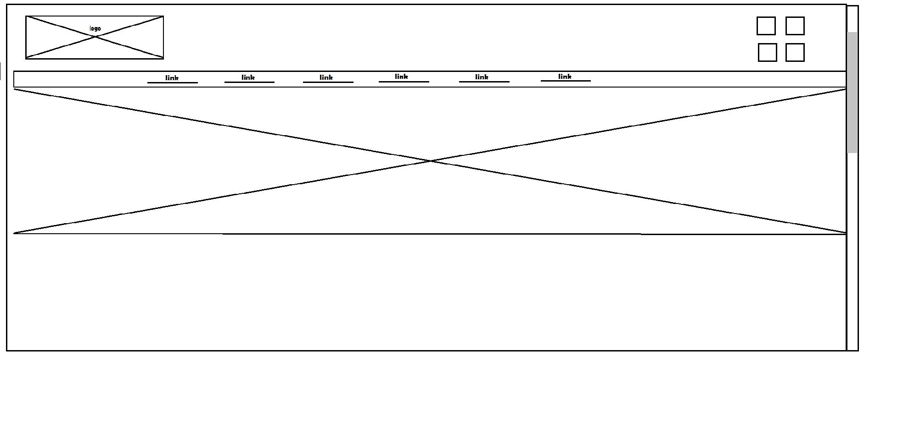

***Contact***

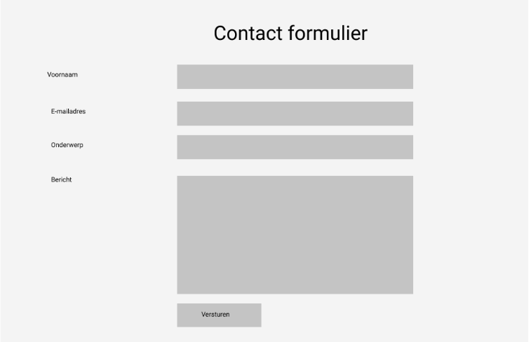

***Login***

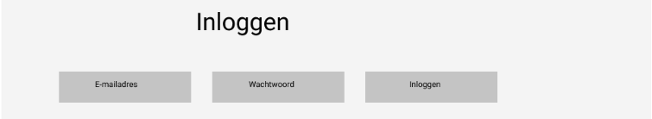

***Reservation***

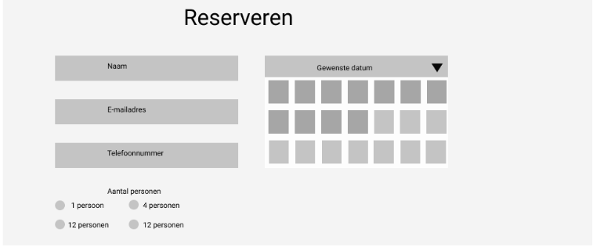

***Book a room***

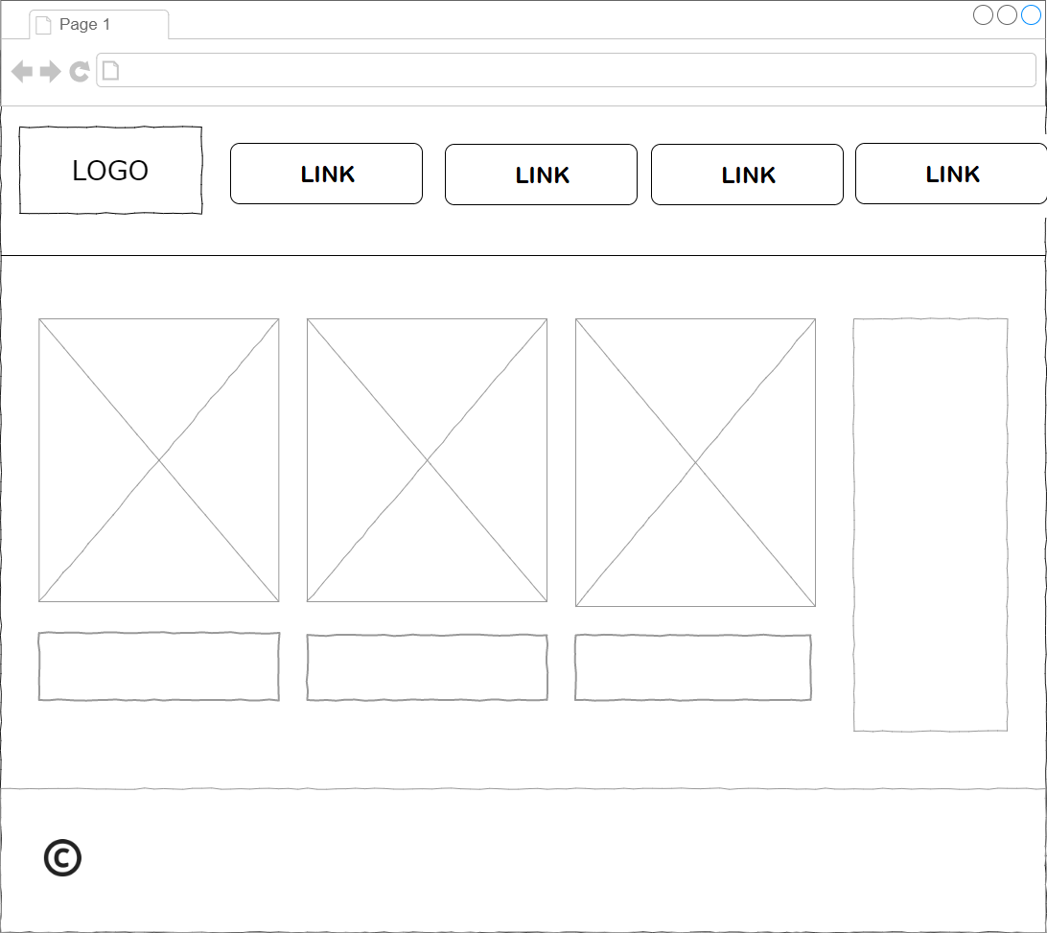

# 9.Datamodel

A Data model shows a logical structure of the database. It also shows the relations and limitations that determine how the data gets saved and how the data will be made accessible. Here is the datamodel diagram:

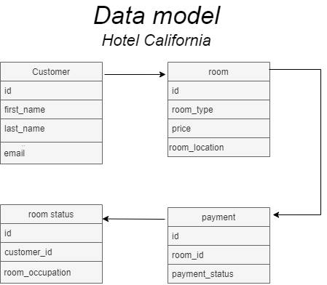

# 10.Security and Access

The security on the Hotel California website consists of a Login for the admin panel and database. No customer is able to access the database or the admin panel. The hotel owner and the staff (by the hotel owner’s choice) is able to access the admin panel and database by their unique encrypted password that will be given once the website is done. All code will be done in PHP and the

Back-end script won’t be open for the public except for the hotel owner and the Programmer that made the script.

# 11.User screens

The website will be made by a Lenovo ideapad 330 15 ich. The specs are:

- 15,6" FHD (1920 x 1080) IPS

- memory:

4 GB DDR4 Intergraded + 8 GB DIMM

- Operating system: Windows 10

* Graphics cart: Tot NVIDIA® GeForce® GTX1050
* AMD Radeon™ 540 (onboard)
* Intel Integrated Graphics

- Processor: Intel® Quad Core i7-8550U From the 8e generatie.

# 12.Version control

|  |  |
| --- | --- |
| *Version* | *Date modified* |
| *1.0* | *10/05/2020* |
| *1.1* | *12/05/2020* |
| *1.2* | *15/05/2020* |
| *1.3* | *17/05/2020* |
| *1.4* | *17/05/2020* |

# 13.Additional

Sources:

Contact sheet: Cheatsheet from D.Verhage

Login register: Cheatsheet from D.Verhage

Reservation: Cheatsheet from D.Verhage

Sitemap: <https://support.google.com/webmasters/answer/156184?hl=nl>

Datamodel: <https://www.lucidchart.com/pages/nl/wat-is-een-databasemodel>

Websites where I can find pictures free of use:

* <https://unsplash.com>
* <https://pexels.com>
* <https://pixabay.com>

Where I can find usable fonts:

* <https://fonts.google.com>